ASSIGNMNET 9

**Read the dataset from the below link**

**https://raw.githubusercontent.com/guipsamora/pandas_exercises/master/06_Stats/US**

**_Baby_Names/US_Baby_Names_right.csv**

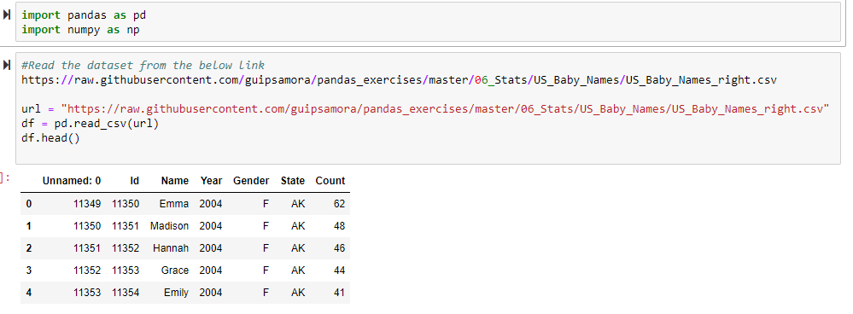

1. Delete unnamed columns

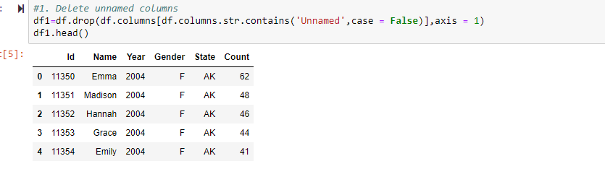

1. Show the distribution of male and female

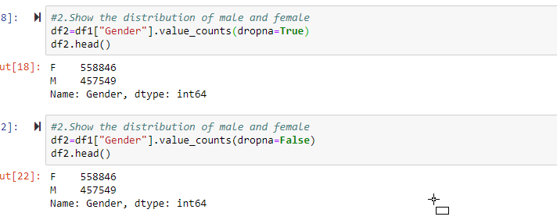

1. Show the top 5 most preferred names

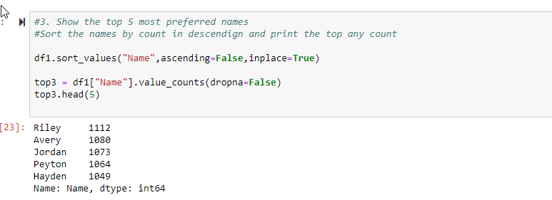

1. What is the median name occurrence in the dataset

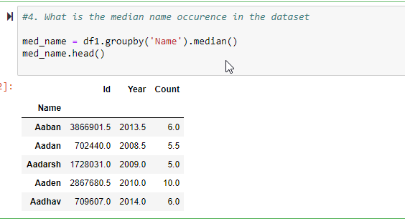

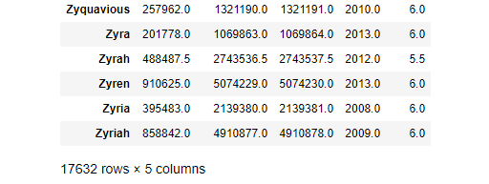

1. Distribution of male and female born count by states

